**Generative AI using LangChain**

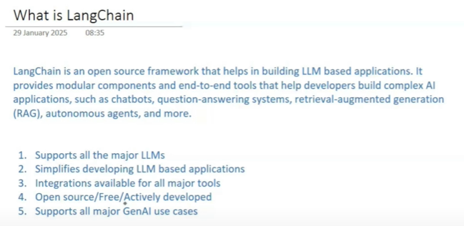

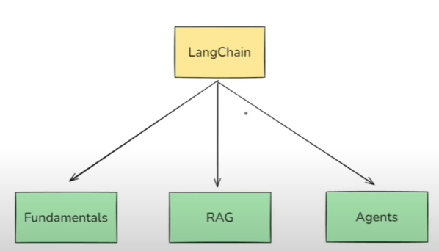

land chain road map

1. fundamentals
2. what is lanchain
3. lanchain components
4. models
5. prompt
6. parsing output
7. runnables and LCEL
8. chains
9. memory
10. RAG
11. document loaders
12. text splitters
13. embeddings
14. vector stores
15. retrievers
16. building a Rag application
17. Agents
18. tools and toolkits
19. tool calling
20. building an AI agent

what is semantic search, explain with example?

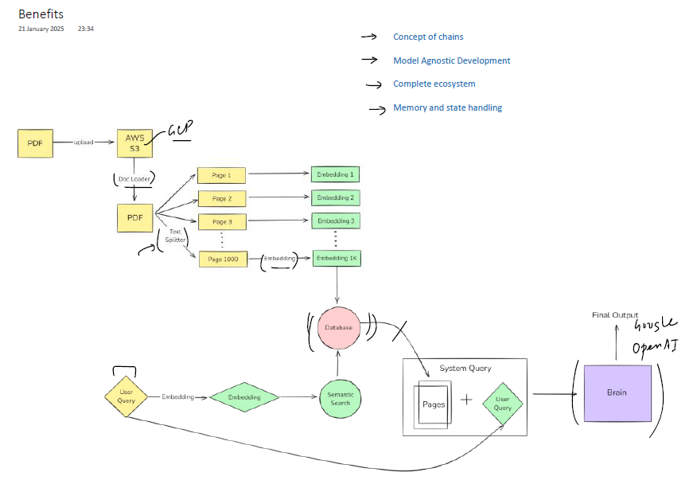

langchain give you built-in functionality for document loader, text splitter, embedding, vector database, also its easy to instract with various LLMs without changing code

in Langchain one component output becomes othercomponent input automatically without writing code

